**

**Softech** **Solutions Inc.**

[www.softechsolutionsgroup.com](http://www.softechsolutionsgroup.com)

[saney.alam@softechsolutionsgroup.com](mailto:saney.alam@softechsolutionsgroup.com%20)

# A Complete Guide for Beginners

Selenium –Data Driven Approach

***Lecture Notes***

Selenium –Data Driven Approach

# **Download Apache POI**

## **Steps to follow:**

1) Go to [Apache POI](http://poi.apache.org/) services and click on ‘**Download**’ on the left side menu.

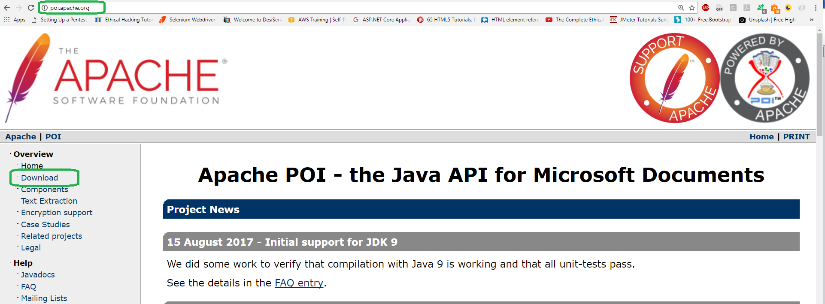

2) You will always get the latest version here. Click on the link for Apache POI under ‘**Available Downloads**‘.

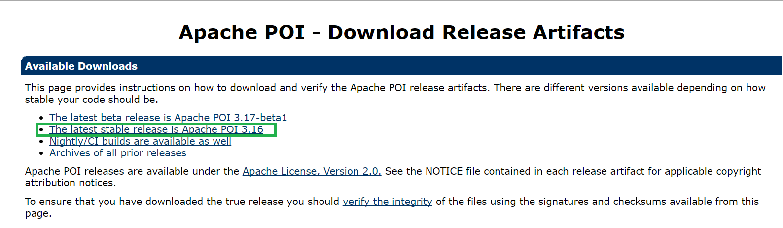

3) Click on the ZIP file to start the downloading.

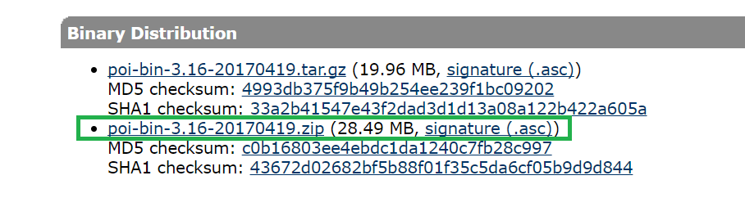

4)  Click on the highlighted link at the top of the page.

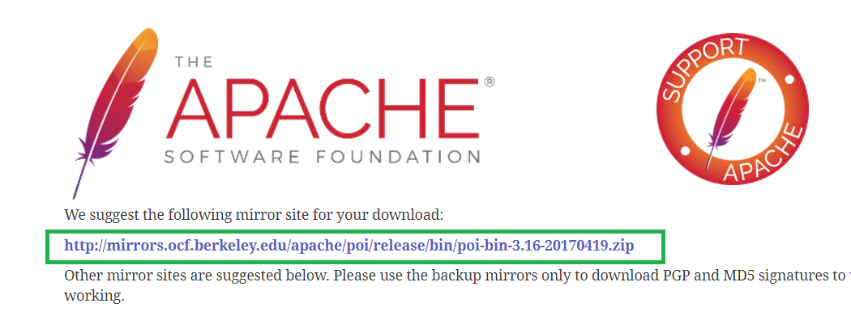

5) Zip file will be saved on the system with in few seconds.



6) Extract the zip file.

# **Adding Apache POI JARS to Project Library**

## **Steps to follow:**

1) Right click the project name, navigate to **Build Path** and select ‘**Configure Build Path**‘.

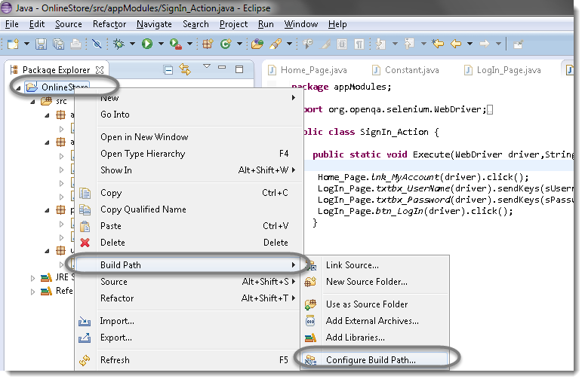

2) Click on **Add External JARS** and navigate to the folder where you have kept the Apache POI jar files.

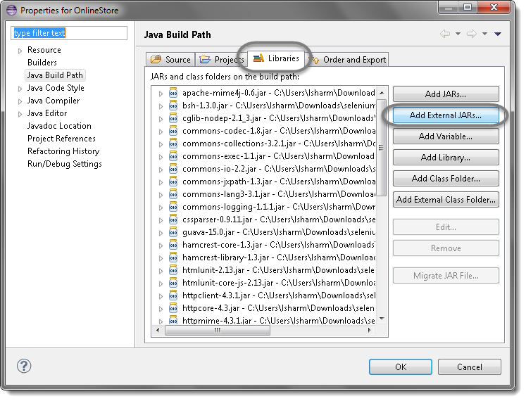

3) Select the Executable Jar files from all the folders.

